Hurricane Ida – A Record-Setting Storm and Its Impacts on Southeast Louisiana
A Preliminary Report

By: Don Wheeler, Meteorologist

For the second time in as many years the Bayou State of Louisiana was devastated by a catastrophic category four hurricane. This year, 2021, the target was southeast Louisiana. Ida made landfall at 11:55AM on August 29 near Port Fourchon, Louisiana with maximum sustained winds of 150 mph.

This is only the third hurricane to make a direct landfall in Louisiana with such ferocious winds. Ida equals that of 2020’s Hurricane Laura that struck southwest Louisiana and that of the 1856 Last Island Hurricane. Based on barometric pressure readings, Laura made landfall with a pressure of 938 millibars, the Last Island Hurricane landed with a pressure of 934 millibars, and Ida came ashore with a pressure of 930 millibars. Therefore, based on wind and pressure criteria, Ida could be classified as the strongest hurricane on record to make landfall in the state. The Last Island Hurricane made landfall only 25 miles to the west-southwest of where Ida came ashore. As a note and according to records, Hurricane Camille in 1969 did not make a direct landfall in the state but did closely brush southeast Louisiana.

Ahead of the storm on August 26 under the Louisiana Homeland Security and Emergency Assistance and Disaster Act, Louisiana Governor John Bel Edwards issued a State of Emergency for Louisiana effective from Thursday, August 26, 2021 to Monday, September 27, 2021, unless terminate sooner. In addition, Governor Edwards sent a formal request to President Joe Biden requesting a presidential emergency declaration for emergency protective measures, evacuation, and sheltering for high-risk areas.
President Biden approved the Presidential Major Disaster Declaration on August 29. The declaration granted the following:
“Individual and Public Assistance Category A, Debris Removal, have been approved for the following parishes: Ascension, Assumption, East Baton Rouge, East Feliciana, Iberia, Iberville, Jefferson, Lafourche, Livingston, Orleans, Plaquemines, Pointe Coupee, St. Bernard, St. Charles, St. Helena, St. James, St. John the Baptist, St. Martin, St. Mary, St. Tammany, Tangipahoa, Terrebonne, Washington, West Baton Rouge, and West Feliciana Parishes.
All 64 Louisiana parishes have been approved for Public Assistance Category B (emergency protective measures), including direct federal assistance, at 75 percent federal funding. In addition, for a period of 30 days from the start of the incident period FEMA is authorized to provide federal funding for Category A and Category B at 100 percent of eligible costs.”

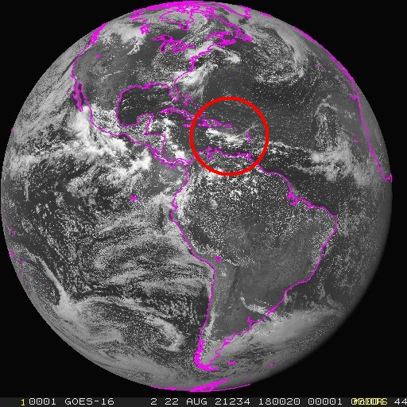
What was to become Ida was in the form of a tropical wave along the Intertropical Convergence Zone (ITCZ). The wave began to show signs of life on August 21 and 22 as it approached and then crossed the Lesser Antilles. Visible satellite images showed clouds associated with the wave in the eastern Caribbean. Tropical weather discussions began mentioning the wave with the 0005Z August 22 report while located near longitude 61° W and latitude 20° N moving west at 15 to 20 knots. The National Hurricane Center labeled the wave as Invest AL092021 at 0600Z on August 24.

Long range computer models (GFS and EMCWF) as of August 23 and 24 were placing a tropical system somewhere in the western Gulf of Mexico making a landfall in northeast Mexico or south Texas. The models quickly shifted the system north and east with a potential landfall, unfortunately, near where Hurricanes Laura and Delta came ashore in 2020. By the 26th, models were in very good agreement with a landfall along the south-central or southeast Louisiana coast; however, because a center had yet to form, much uncertainty remained as to its final destination. In addition, models were also beginning to indicate the system could develop into a strong hurricane in the Gulf of Mexico.

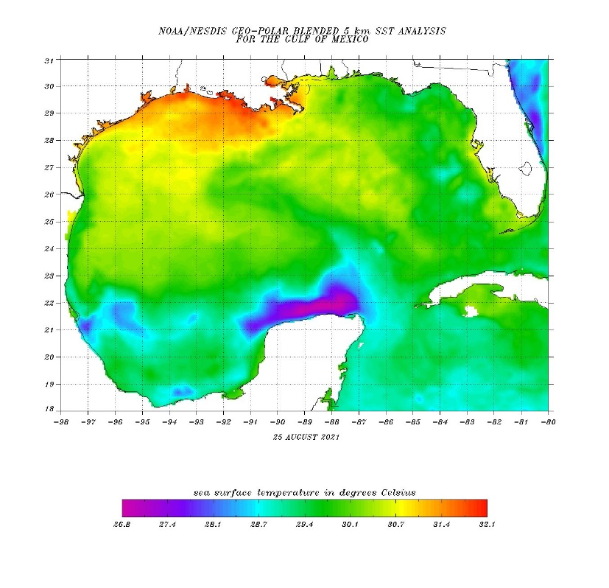
Conditions in the gulf were ripe for rapid intensification, and with time, those conditions became even more evident with model runs. Upper level winds were forecast to be very favorable for rapid intensification with low wind sheer. Very warm sea-surface temperatures were also present, especially along the northern gulf off of the Louisiana coast where values were in the upper 80s to the 90 degree mark. Ida would cross an area of higher sea-surface temperatures that stretched from western Cuba northwestward toward the Louisiana coast.
Sea Surface Temperatures Courtesy of NOAA/NESDIS

On the morning of August 26 at 11AM EDT, the tropical wave continued to organize and was upgraded to Tropical Depression #9 115 miles SSW of Negril, Jamaica. The storm wasted no time in reaching tropical storm status and was upgraded to Tropical Storm Ida at 5:20PM EDT, just over six hours after becoming a depression.

Since a center of circulation had been defined, models continued to hone in on a potential landfall. At the time the storm was classified as a depression, the first official forecast track was released. It had the system making landfall as a strong category two hurricane Sunday night, August 29, just east of Marsh Island in Atchafalaya Bay. The final landfall was approximately 75 miles to the east near Port Fourchon as a strong category four storm midday on Sunday – a rather impressive feat for a tropical system nearly four days out.
Courtesy of Tropical Tidbits
Ida forecast tracks four days prior to landfall.

At 10PM CDT, Thursday, August 26, the National Hurricane Center issued watches for portions of the northern gulf coast. A hurricane watch extended from Cameron, Louisiana to the Mississippi/Alabama border which included Lake Pontchartrain, Lake Maurepas, and metropolitan New Orleans. A tropical storm watch extended eastward from the Mississippi/Alabama border to the Alabama/Florida border – 61 hours and 55 minutes before actual landfall.

Ida began her first significant intensification phase on the morning of August 27, while north-northwest of Grand Cayman and quickly reached hurricane status with 75 mph winds by 1:15 PM EDT while 75 miles southeast of the Isle of Youth. At 5PM EDT, hurricane warnings were issued from Intracoastal City, Louisiana to the Mouth of the Pearl River which included Lake Pontchartrain, Lake Maurepas, and metropolitan New Orleans – 43 hours and 55 minutes prior to actual landfall. Inland hurricane warnings were issued across southeast Louisiana to the Mississippi border with tropical storm warnings issued for much of the eastern half of Louisiana and nearly all of south Mississippi.
Ida becomes a hurricane. Bayou State Weather GOES Receiving Station

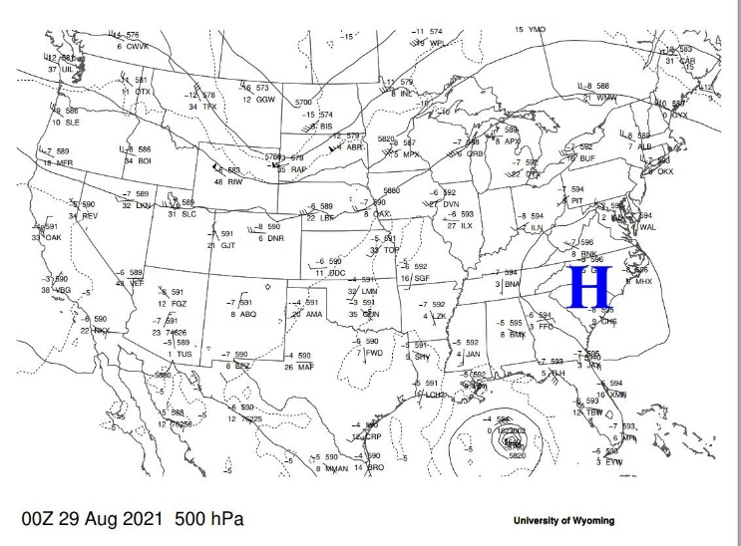
Ida’s forecast track was becoming increasingly more confident as computer models were more consistent in bringing Ida around the southwest and then western periphery of a large upper level high located over the southeastern U.S. The storm was also forecast to slow around the time of landfall as Ida began to turn north around the western side of the upper high. Otherwise, conditions in the southeastern and northern gulf continued to support rapid intensification once Ida emerged off of the western tip of Cuba.
Courtesy of University of Wyoming

During the early morning hours of August 28 at 2AM EDT, Ida moved off of the western tip of Cuba and into the southeastern Gulf of Mexico 150 miles west-northwest of Havana, Cuba or 560 miles southeast of New Orleans with maximum sustained winds of 80 mph. As forecast, Ida began to intensify once again. At 10AM CDT winds had increased to 85 mph, then to 100 mph at 1PM CDT, and 105 mph by 7PM CDT. Confidence was quite high in that Ida would make landfall as a very dangerous major hurricane.

At 1AM CDT, Ida attained major hurricane status with 115 mph sustained winds (category 3) while 105 miles south-southeast of the Mouth of the Mississippi River and forecast to continue intensification. A special advisory was issued only an hour later indicating that the storm had strengthened to a category four hurricane with winds of 130 mph. Over the course of the remaining overnight hours rapid intensification continued with Ida reaching 140 mph sustained winds while 75 miles south of the Mouth of the Mississippi River. By 6AM CDT, Ida peaked with maximum sustained winds of 150 mph! Offshore buoys were reporting sustained hurricane force winds gusting to over 100 mph. While the sustained winds remained at 150 mph until landfall, the minimum central pressure continued to drop and reached its lowest point at 930mb/27.46 inches of mercury at 8AM CDT.

At 9AM CDT, Ida’s northern eyewall began to skirt the area near Port Fourchon and Grand Isle. A C-MAN station near Southwest Pass, Louisiana reported a sustained wind of 102 mph with gusts to 116 mph. Another nearby station reported sustained winds of 97 mph gusting to 121 mph.

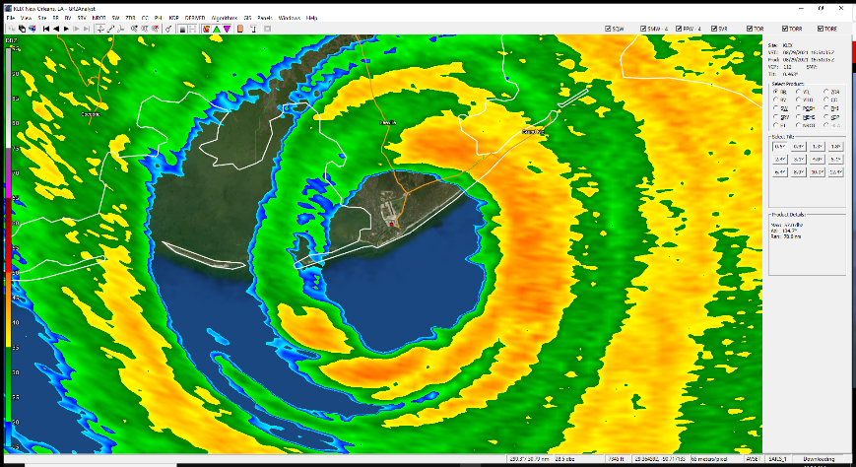
Ida made landfall a few miles to the west-southwest of Port Fourchon, Louisiana at 11:55 AM CDT as a strong category four hurricane with sustained winds of 150 mph and a minimum central pressure of 930mb/27.46 inches of mercury. Ida continued inland and began a slow weakening process as she headed toward Houma, Louisiana. While Houma did sustain significant wind damage, the storm began its anticipated northward motion and the actual center passed five miles east of the city.
Radar image of Ida making landfall near Port Fourchon which is seen in the eye.

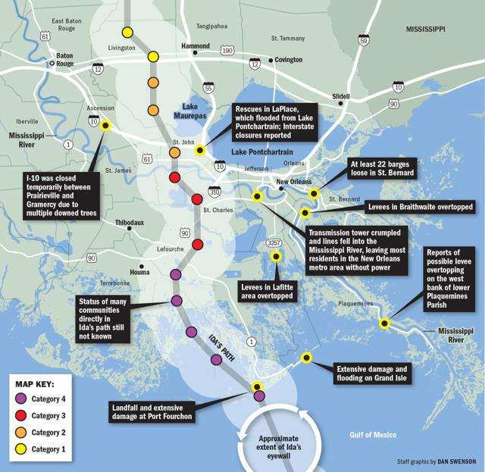
Ida continued northward, even making some erratic turns on its path through eastern Terrebonne and central Lafourche Parishes. As predicted, the storm also slowed in its forward speed as it made its turn around the western periphery of the upper level high. Also of note, the storm was maintaining its category four status a bit longer than anticipated. It has been suggested that because the storm was moving over saturated and swampy ground, it was able to tap into available energy from the water slowing its weakening process. This phenomenon is known as the “Brown Ocean Effect” and may or may not have had an influence on the system and will be reserved for future studies. In addition, the storm was just completing a rapid intensification phase which could have slowed the weakening process as the momentum of the storm was at a point of upswing as it made landfall and was beginning an eyewall replacement cycle.
Courtesy of NOLA.com

Ida maintained category four status through 6PM CDT, just over six hours after landfall. Maximum sustained winds had decreased to 125, still a major category three storm, while five miles east of Houma. At 9PM CDT, she dropped below major hurricane status with 110 mph sustained winds while 40 miles east-southeast of Baton Rouge. Ida maintained major hurricane status (category 3 or higher) for 9 hours and 5 minutes after making landfall!

Ida’s motion continued slow northerly, moving to the north-northwest at only 9 mph. The slow motion allowed for prolonged high winds near and to the east of the center along with torrential heavy rainfall which was also becoming a concern. Radar estimates were showing in excess of 8-inches had fallen along and to the east of the center. Those same estimates also showed a very sharp line of relatively little rain to the west of the center and excessive amounts just a few miles to the east. 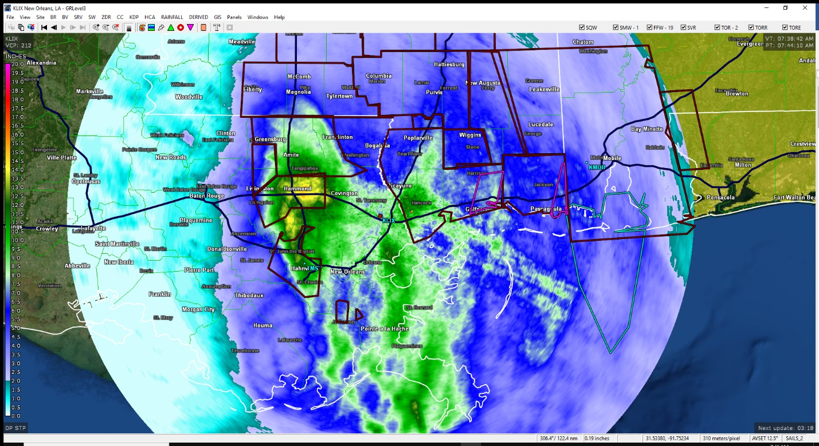
Radar estimates showing sharp contast between relatively low rainfall amounts (light blue) and very heavy amounts in excess of 8-inches (dark blue, greens, and yellows)

As is typical with many landfalling hurricanes along the gulf coast, dry air often becomes entrained into the system causing more rapid weakening as well as a marked decrease in rainfall intensity to the left of motion of the storm. In the case of Ida, this also occurred as the center approached the I-10 corridor. Radar and satellite imagery indicated that dry air became entrained into the storm cutting off rainfall in the western and southern semicircles.
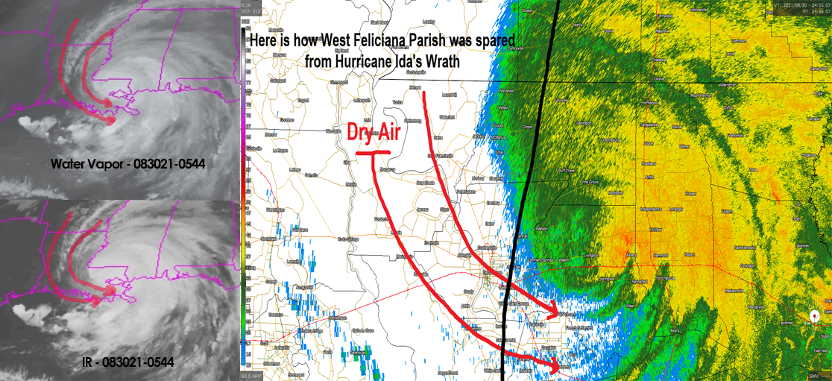
Image depicting dry air entraining into the system. Courtesy of St. Francis Weather Center.

St. John the Baptist, eastern portions of Livingston, and Tangipahoa Parishes saw in excess of a foot of rainfall with the passage of Ida. Some radar returns near and just to the east of Hammond indicated nearly 16-inches may have fallen resulting in extensive flooding.

As of the 1AM CDT advisory on August 30, Ida had dropped to minimal hurricane status with 75 mph sustained winds 20 miles south-southwest of Greensburg, Louisiana or 45 miles south-southwest of McComb, Mississippi and continued to move slowly north at 9 mph. Ida was downgraded to a tropical storm as of the 4AM CDT advisory with sustained winds of 60 mph, 50 miles north-northeast of Baton Rouge, Louisiana. All hurricane warnings were discontinued and replaced with tropical storm warnings.

Ida was finally downgraded to a tropical depression 20 miles north-northwest of Jackson, Mississippi at 4PM CDT on August 30. All tropical storm warnings were discontinued as the weakened system continued its northward trek through Mississippi dumping heavy rainfall along and east of the center.

Because Ida maintained its intensity for a prolonged period of time following landfall along with a slowed forward speed, extensive property damage along and east of the center occurred. The storm decimated electrical grids across nearly all of southeast Louisiana leaving over a million customers without power. Local electrical companies struggled to establish a timeline for repair due to the number of new cables and poles that would need replacing. Terrain restrictions through swampy areas along with damaged vegetation and structures would also be a factor in repair estimates.

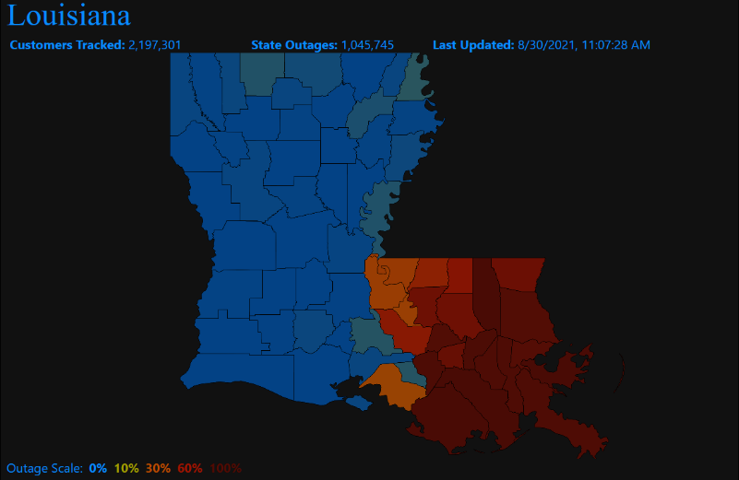
Four primary areas of focus stood out with regard to power outages: Baton Rouge, Hammond, New Orleans, and the parishes along the coast where Ida made landfall (Terrebonne, Lafourche, Plaquemines, St. Charles, Jefferson, St. James, and St. John the Baptist). Baton Rouge, being on the weaker western side of the storm, was brought back online relatively soon after the storm. Restoration in New Orleans began to come online next followed by the Hammond area. The more heavily damaged areas of the southern parishes were looking at an extended period of time without power restoration.
Courtesy of PowerOutage.us

Two weeks after Ida’s devastating landfall, over 150,000 customers in Louisiana remained without power. Nearly all of the Baton Rouge and New Orleans metropolitan areas had been repaired. Just under 30% of badly damaged Tangipahoa Parish, which includes the city of Hammond, remained without power. The southern parishes of Terrebonne, Lafourche, and St. Charles where much of Ida’s strong winds were concentrated were still 85% without power after two weeks.

Significant structural damage from wind was widespread along and east of the center. Exceptional damage was noted across Terrebonne, Lafourche, St. Charles, St. James, lower Jefferson, and St. John the Baptist Parishes. Some select municipalities include, but not exclusive, were Grand Isle, Houma, Golden Meadow, Lockport, and Thibodaux.

Storm surge was also a significant factor in damage. An estimated storm surge of 12-16 feet was anticipated along and to the right of the center from Port Fourchon to the Mouth of the Mississippi River with 8-12 feet forecast across the remainder of southeast Louisiana from Morgan City eastward. Surges of 4-8 feet were forecast along the shores of Lakes Maurepas and Pontchartrain and were verified by local media and social media reports. Fortunately, improvements to the levee systems in and around New Orleans following Hurricane Katrina proved to be effective.

Hurricane Ida will go down as one of the strongest hurricanes to make a direct landfall in Louisiana, if not the strongest hurricane if one considers both highest wind and lowest pressure. The intensity of the storm in combination with its slow movement caused severe wind damage to structures and the electrical grid across nearly all of southeast Louisiana. With each landfalling storm in our state, we continue to make improvements in our infrastructure to minimize the damage when the next hurricane strikes. While repairs to the electrical grid were remarkable, studies will likely be conducted as to how such extensive damage can be prevented and how alternative or temporary services can be rendered while repairs are being made.

Timeline

August 21-22
- What will become Ida is identified as a tropical wave in the Tropical Weather Discussion
- 0005Z August 22 - An Atlantic tropical wave extends its axis along 61W from 20N southward to Venezuela, and moving W at 15 to 20kt.

August 23
- 1805Z August 23 – A robust Caribbean tropical wave is near 64W from 20N southward across the Virgin Islands to E Venezuela, and moving W near 10 kt.

August 24
- 1805Z August 24 – A Caribbean tropical wave has its axis along 67W, south of 20N, and it is moving W at 10 to 15kt. A recent scatterometer satellite pass indicates that it has a broad curvature with fresh to strong trades covering most of the central and eastern Caribbean. The NHC is also tracking this disturbance for possible tropical development over the next 5 days and has labeled the system as Invest AL092021.

August 25
- 1805Z August 25 – A robust tropical wave over the central Caribbean Sea is producing a large area of disorganized showers and thunderstorms, mainly south of 17N and between 71W to 78W. A broad area of low pressure is expected to form over the SW Caribbean Sea during the next day or so. A recent scatterometer satellite pass indicates fresh to strong trades over the NE quadrant of the disturbance. Environmental conditions are forecast to be conductive for development, and a tropical depression or tropical storm is likely to form late this week or over the weekend. The system is expected to move northwestward over the northwestern Caribbean Sea and near or across the Yucatan Peninsula of Mexico on Friday and into the Gulf of Mexico this weekend where conditions are expected to be favorable for additional development.

August 26
- 1500Z 11AM EDT Tropical Depression 9 Forms 115 miles SSW of Negril, Jamaica with 35 mph sustained winds.
- 2320Z 5:20PM EDT Air Force plane finds that the tropical depression has strengthened to Tropical Storm Ida with maximum sustained winds of 40 mph with higher gusts.
- 11PM EDT/10PM CDT A Hurricane Watch is issued from Cameron, Louisiana to the Mississippi/Alabama border including Lake Pontchartrain, Lake Maurepas, and metropolitan New Orleans. A Tropical Storm Watch is issued from the Mississippi/Alabama border to the Alabama/Florida border.
- Louisiana Governor John Bel Edwards declares a State of Emergency for Louisiana.

August 27
- 0900Z 5AM EDT Ida begins to strengthen 50 miles NNW of Grand Cayman with maximum sustained winds of 45 mph.
- 1500Z 11AM EDT Ida continues strengthening 75 miles SE of the Isle of Youth with 65 mph sustained winds.
- 1710Z 1:15PM EDT Ida strengthens to a hurricane. Air Force Reserve hunter aircraft indicate that Ida has strengthened into a hurricane with maximum sustained winds of 75 mph 30 miles ESE of the Isle of Youth.
- 2100Z 5PM EDT Maximum sustained winds increase to 80 mph 45 miles NW of the Isle of Youth. Hurricane Warnings issued from Intracoastal City, Louisiana to the Mouth of the Pearl River, including Lake Pontchartrain, Lake Maurepas, and metropolitan New Orleans. Tropical Storm Warnings issued from the Mouth of the Pearl River to the Mississippi/Alabama border and west of Intracoastal City to Cameron, Louisiana.
- Rapid intensification forecast once the storm moves into the Gulf of Mexico.

August 28
- 0600Z 2AM EDT Ida moves into the southeastern Gulf of Mexico 150 miles WNW of Havana, Cuba or 560 miles SE of New Orleans, Louisiana. Maximum sustained winds remain at 80 mph.
- 1500Z 10AM CDT Ida begins to intensify with 85 mph sustained winds 350 miles SSE of the Mouth of the Mississippi River or 435 miles SE of Houma, Louisiana. Tropical Storm Warning extended east to the Alabama/Florida border.
- 1800Z 1PM CDT Intensification continues. Maximum sustained winds at 100 mph with a minimum central pressure of 976mb/28.82”. 290 miles SSE of the Mouth of the Mississippi River or 380 miles SE of Houma, Louisiana.
- 2100Z 7PM CDT Maximum sustained winds at 105 mph with a minimum central pressure of 976mb/28.82”. Location is 240 miles SSE of the Mouth of the Mississippi River or 325 miles SE of Houma, Louisiana. Intensification has temporarily stabilized with intensification expected to resume.
- Forecast to be an extremely dangerous major hurricane at landfall.

August 29
- 0600Z 1AM CDT Ida strengthens to a major Category 3 hurricane with 115 mph sustained winds and a minimal pressure of 955mb/28.20”. Located 105 miles SSE of the Mouth of the Mississippi River or 185 miles SE of Houma, Louisiana. Continued strengthening forecast.
- 0700Z 2AM CDT Ida continues to rapidly strengthen and is now a Category 4 hurricane with maximum sustained winds of 130 mph and a minimal pressure of 949mb/28.02”. Location is 100 miles S of the Mouth of the Mississippi River or 175 miles SE of Houma, Louisiana.
- 0900Z 4AM CDT Ida strengthens further with 140 mph sustained winds as a dangerous Category 4 hurricane. Minimal central pressure is 946mb/27.94”. Location is 75 miles S of the Mouth of the Mississippi River or 145 miles SE of Houma, Louisiana. Movement is NW at 15 mph.
- 1000Z 5AM CDT Strengthening continues with maximum sustained winds of 145 mph and a minimal central pressure of 946mb/27.93”. Location is 80 miles SSE of Grand Isle, Louisiana or 65 miles S of the Mouth of the Mississippi River. Motion NW at 15 mph.
- 1100Z 6AM CDT Ida now a very strong and dangerous Category 4 hurricane with maximum sustained winds of 150 mph and a minimal central pressure of 935mb/27.61”. Location 75 miles SSE of Grand Isle, Louisiana or 60 miles SSW of the Mouth of the Mississippi River. Motion NW at 15 mph. NOAA C-MAN station at Pilot’s Station East near Southwest Pass, Louisiana reported sustained wind of 82 mph with a gust to 107 mph.
- 1200Z 7AM CDT Ida maintains its maximum sustained winds at 150 mph with the lowest pressure reported thus far at 933mb/27.55”. Location is now 50 miles SW of the Mouth of the Mississippi River or 100 miles SE of Houma, Louisiana. Motion continues NW at 15 mph.
- 1300Z 8AM CDT Ida located 50 miles SSE of Grand Isle, Louisiana or 100 miles SSE of New Orleans, Louisiana with maximum sustained winds of 150 mph. Motion remains NW at 15 mph. Pressure continues to drop and now at 930mb/27.46”. Elevated NOAA C-MAN station at Southwest Pass, Louisiana reported a sustained wind of 105 mph gusting to 121 mph.
- 1400Z 9AM CDT Northern eyewall approaching the coast near Grand Isle. Center is 40 miles SSE of Grand Isle or 90 miles SSE of New Orleans, Louisiana. Maximum sustained winds remain near 150 mph moving to the NW at 14 mph. Pressure remains at 930mb/27.46”. Elevated C-MAN station at Southwest Pass, Louisiana reported a sustained wind of 102 mph gusting to 116 mph with another station at Pilot’s Station East reporting a sustained wind of 97 mph gusting to 121 mph.
- 1600Z 11AM CDT Northern eyewall moving onshore. Center of Ida is 25 miles SSW of Grand Isle, Louisiana or 60 miles SE of Houma, Louisiana. Maximum sustained winds remain near 150 mph with the central pressure at 933mb/27.55”.
- 1655Z 1155AM CDT Ida makes landfall near Port Fourchon, Louisiana with maximum sustained winds of 150 mph and a minimum central pressure of 930mb/27.46”. This is 15 miles SW of Grand Isle, Louisiana or 45 miles SE of Houma, Louisiana. Motion is NW at 13 mph. New Orleans Lakefront Airport reported sustained winds of 43 mph and a gust to 67 mph.
- 1800Z 1PM CDT Ida continues to push inland but maintaining intensity. Maximum sustained winds remain near 150 mph located 20 miles W of Grand Isle, Louisiana or 55 miles SSW of New Orleans. Minimum pressure remains at 930mb/27.46”. Motion is NW at 13 mph. Hurricane force winds extend outward up to 50 miles from the center with tropical storm force winds outward up to 150 miles.
- 1900Z 2PM CDT Ida makes a second landfall southwest of Galliano, Louisiana. Maximum sustained winds are now at 145 mph with a central pressure of 934mb/27.58”. Motion was NW at 12 mph. Wind speeds reported in the past hour were Golden Meadow with sustained of 70 mph gusting to 107 mph, Dulac with a sustained wind of 76 mph gusting to 104 mph, and New Orleans Lakefront Airport reported a gust to 76 mph.
- 2100Z 4PM CDT Ida slows as it moves across south Louisiana and is slow to weaken. Maximum sustained winds remain near 130 mph (Category 4) with the motion to the NW at 10 mph. The center was located 45 miles SW of New Orleans or 70 miles SSE of Baton Rouge. Pressure had risen to 938mb or 27.70”. Hurricane force winds extend outward 45 miles from the center and tropical storm force winds extend outward 150 miles from the center. Dulac, Louisiana reported sustained winds of 93 mph with a gust to 135 mph. South Lafourche Airport reported a sustained wind of 91 mph gusting to 122 mph. Lakefront Airport in New Orleans reported a gust to 82 mph.
- 2200Z 5PM CDT Ida maintains Category 4 status 5 miles E of Houma, Louisiana or 40 miles SW of New Orleans. Maximum sustained winds remain at 130 mph with a central pressure of 938mb/27.70”.
- 2300Z 6PM CDT Ida drops to Category 3 status with sustained winds at 125 mph. The center was located 5 miles E of Houma or 30 miles SW of New Orleans. Motion was NW at 10 mph. Minimum pressure was 941mb/27.79”. New Orleans Lakefront Airport reported a sustained wind of 66 mph gusting to 84 mph. South Lafourche Airport reported a sustained wind of 79 mph gusting to 103 mph.
- 0200Z (8/30) 9PM CDT Ida drops below major hurricane status with sustained winds of 110 mph 30 miles WSW of New Orleans, Louisiana or 40 miles ESE of Baton Rouge, Louisiana. Minimum central pressure was 950mb/28.05”. Motion was NW at 9 mph. Based on advisories, Ida maintained major hurricane status while over land (winds of 115 mph or higher) for 9 hours, 5 minutes. (Landfall was at 11:55 AM).
- 0300Z (8/30) 10PM CDT The center of Ida was 30 miles ESE of Baton Rouge or 40 miles WSW of New Orleans moving slowly NNW at 9 mph. Maximum sustained winds were 105 mph with a minimum central pressure of 953mb/28.15”.
- President Biden approved the Presidential Major Disaster Declaration

August 30
- 0600Z 1AM CDT This is the last advisory on Ida as a hurricane. Maximum sustained winds are at 75 mph with the center located 20 miles SSW of Greensburg, Louisiana or 45 miles SSW of McComb, Mississippi. Ida continues to move slowly N at 9 mph. Minimum central pressure was 972mb/28.70”.
- 0900Z 4AM CDT Ida downgraded to a tropical storm 95 miles SSW of Jackson, Mississippi or 50 miles NNE of Baton Rouge, Louisiana. Maximum sustained winds were 60 mph. Motion to the N at 8 mph. Minimum central pressure was 990mb/29.24”. All hurricane warnings discontinued and replaced with a Tropical Storm Warning from Grand Isle to the Mouth of the Pearl River, including Lake Pontchartrain, Lake Maurepas, and metropolitan New Orleans.
- 1800Z 1PM CDT Final advisory of Ida as a tropical storm. Winds had decreased to 40 mph while located 20 miles WSW of Jackson, Mississippi. Motion was NNE at 9 mph with a minimal central pressure of 997mb/29.45”.
- 2100Z 4PM CDT Ida downgraded to a tropical depression 20 miles NNW of Jackson, Mississippi with maximum sustained winds of 35 mph. Motion was NNE at 9 mph with a minimal central pressure of 999mb/29.50”. All tropical storm warnings and storm surge warnings discontinued.

Supporting Images

Progression of Ida Satellite Images (Courtesy of the University of Wisconsin)

 | 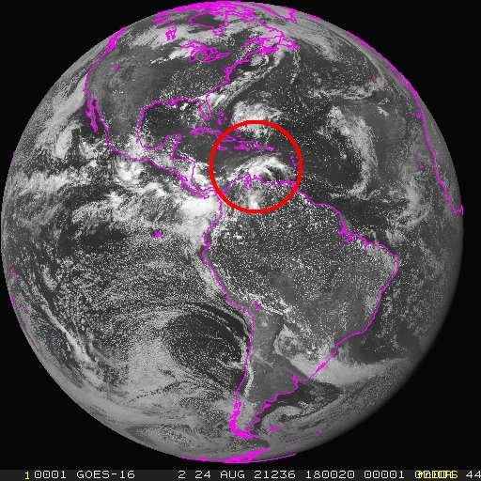
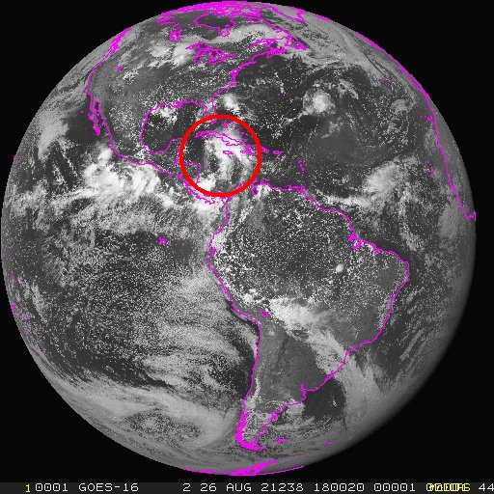 | 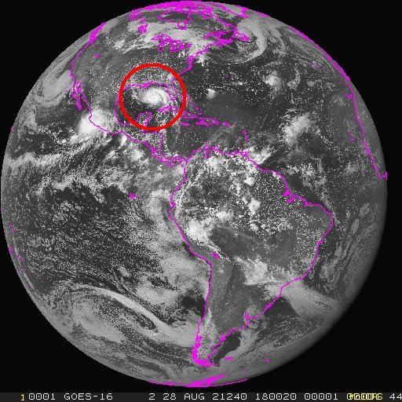

High Resolution GOES-16 Imagery from Bayou State Weather

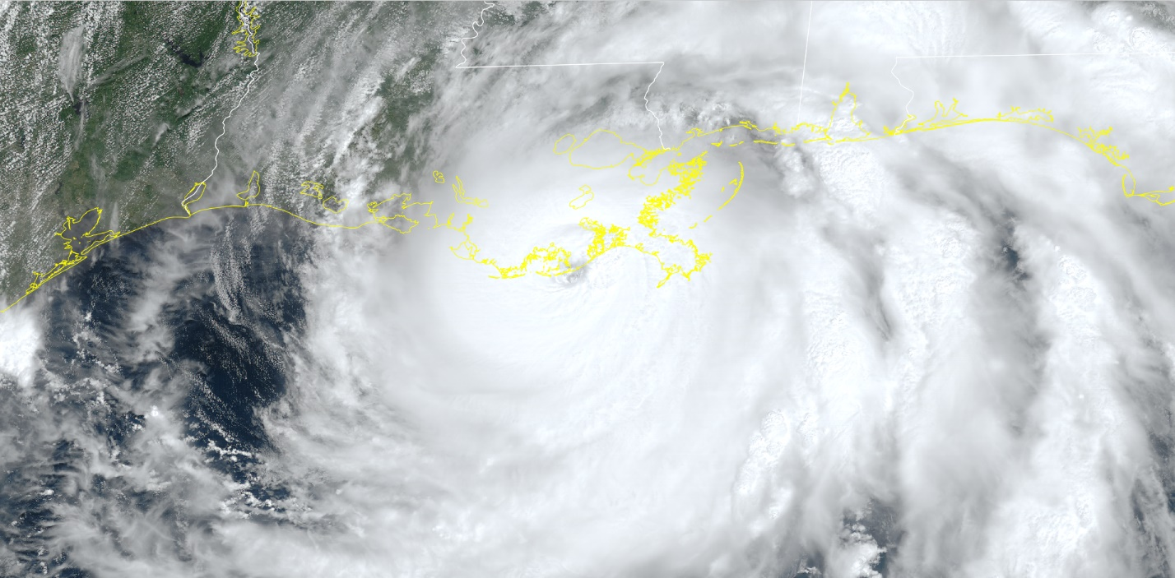

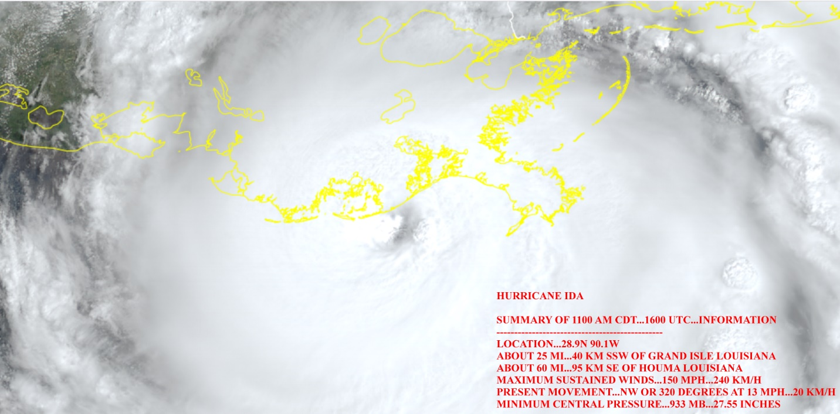

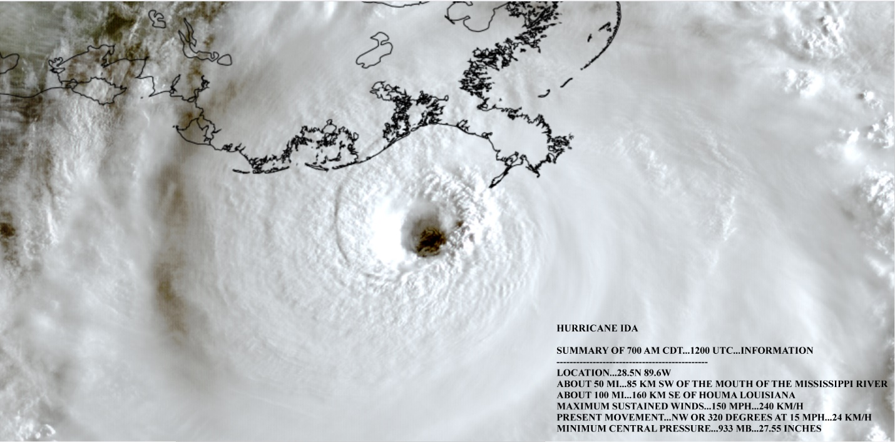

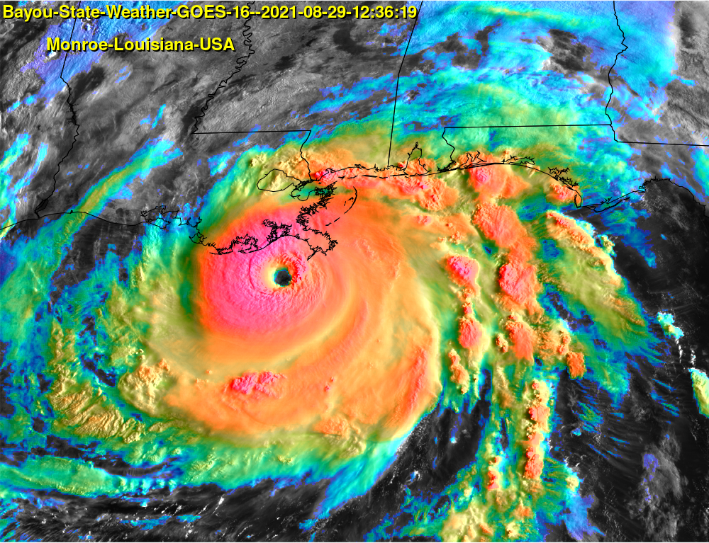

Radar Imagery

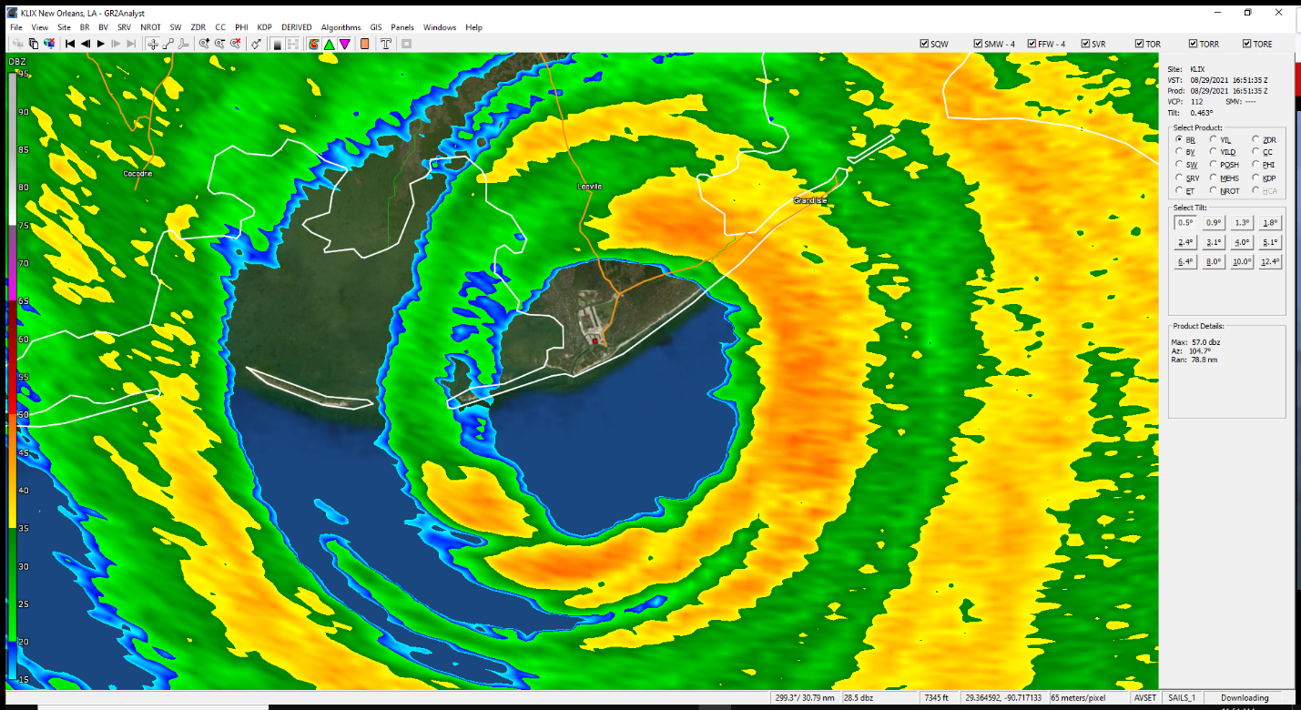
Ida making landfall near Port Fourchon.

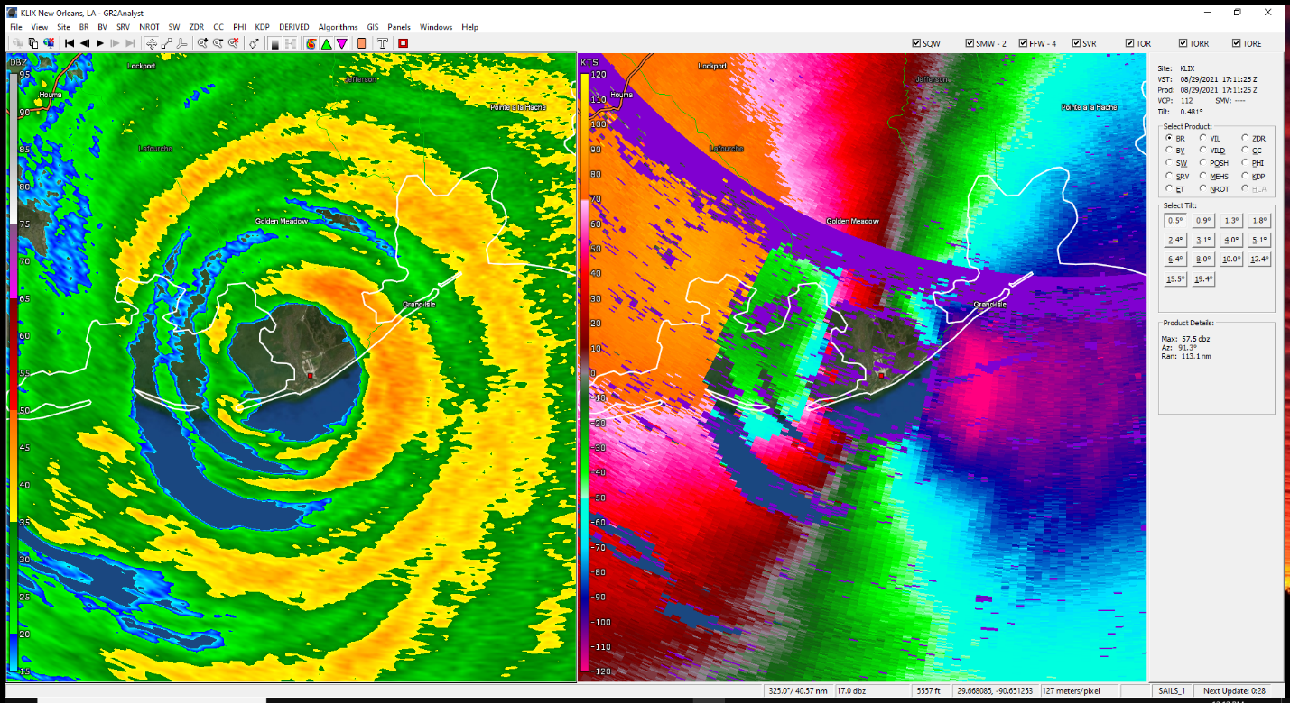
Reflectivity (left) and Velocity (right)

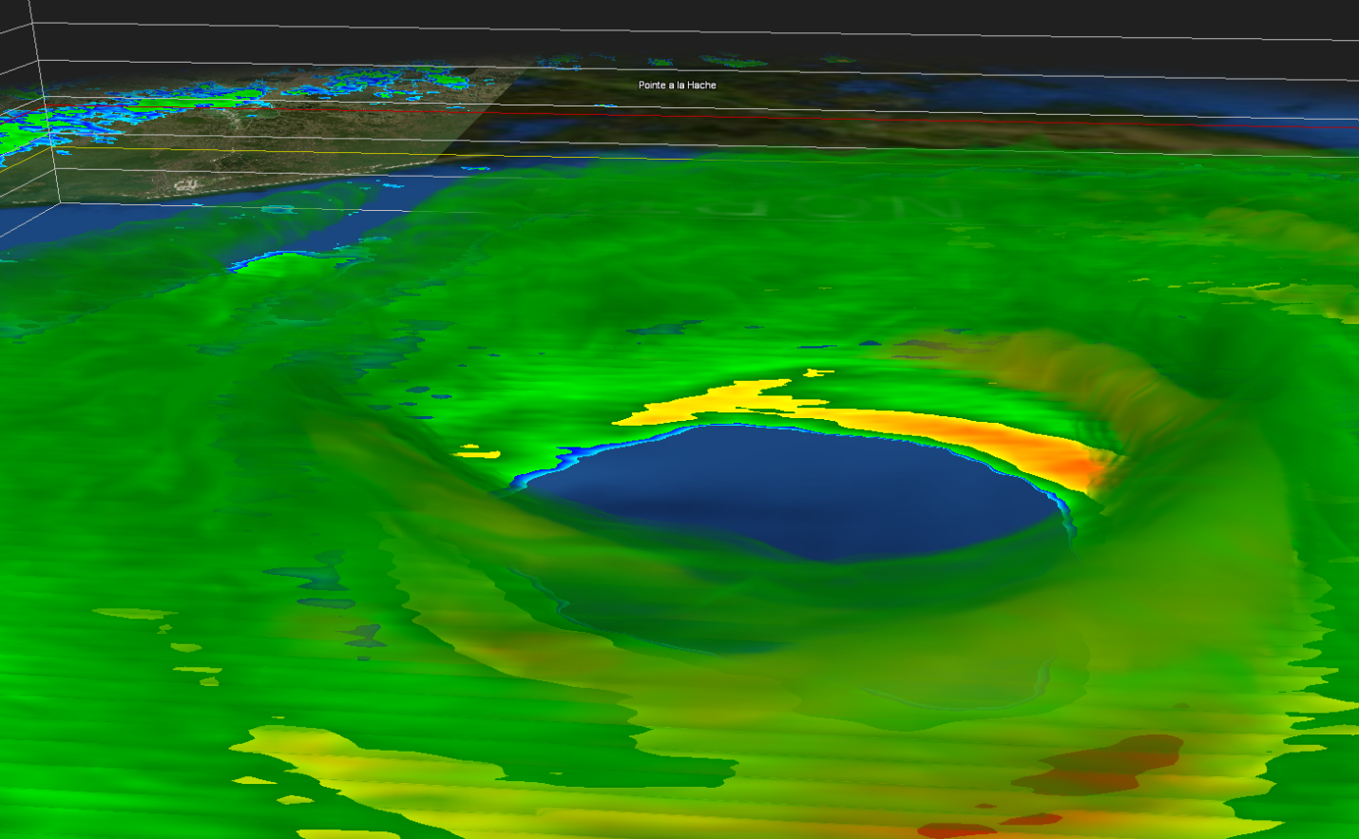

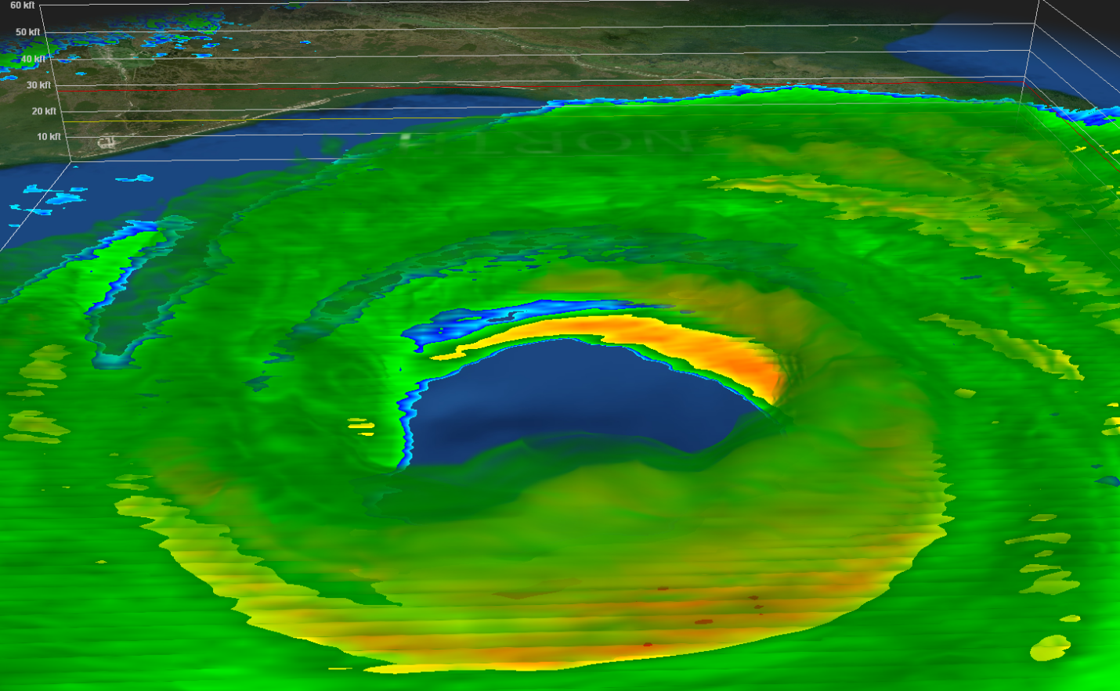
3-D Images of the eye as Ida approaches the coast.

Hurricane Ida Track

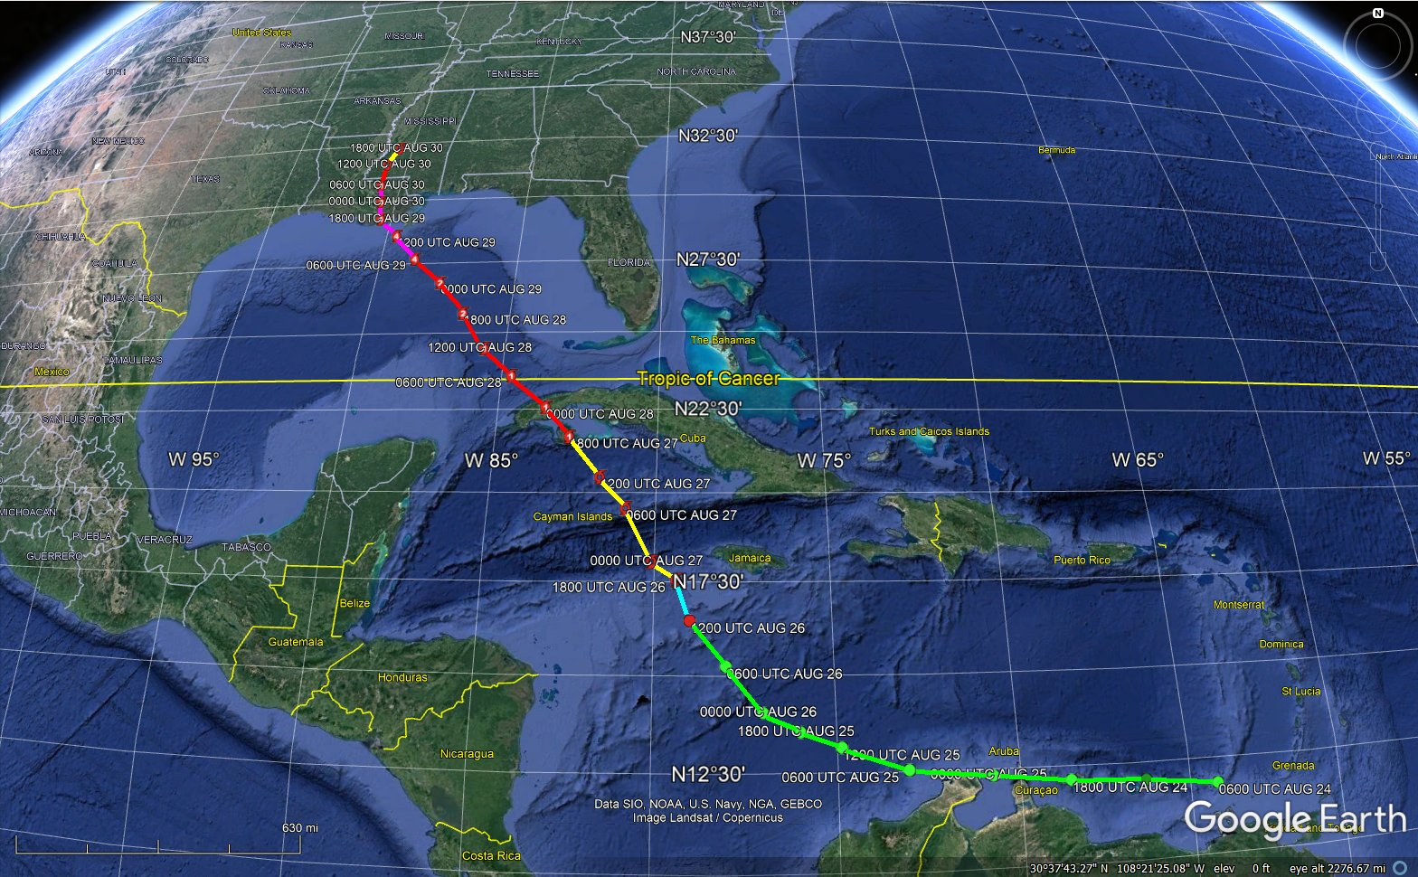

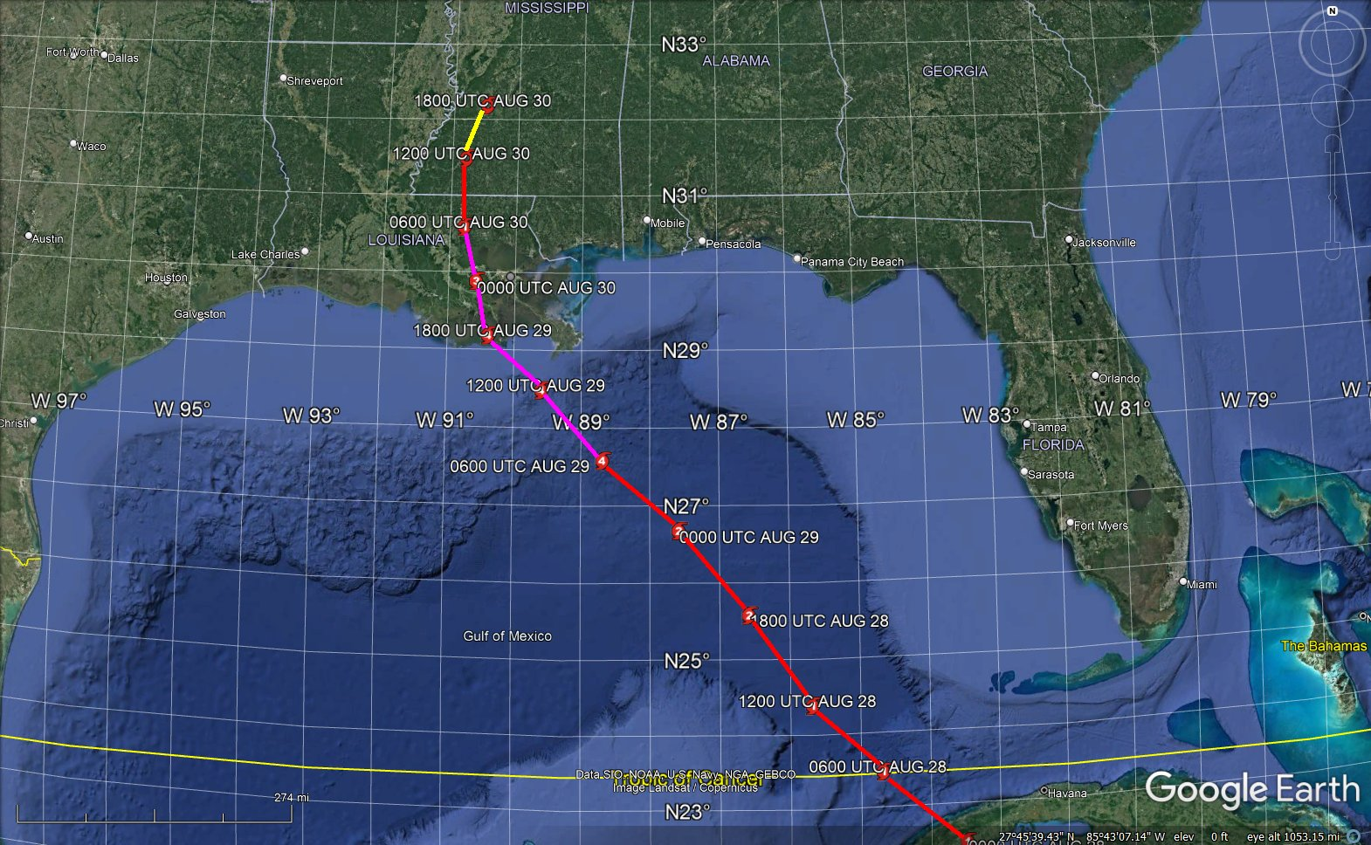

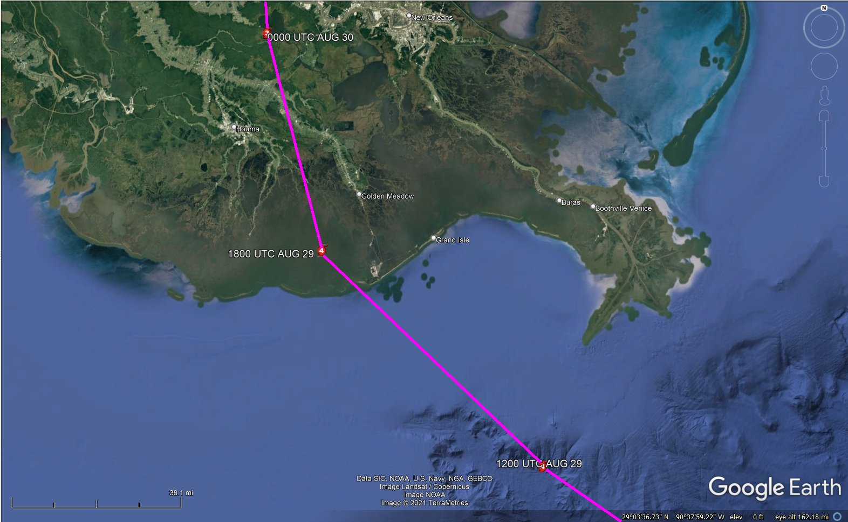

Power Outages and Repairs

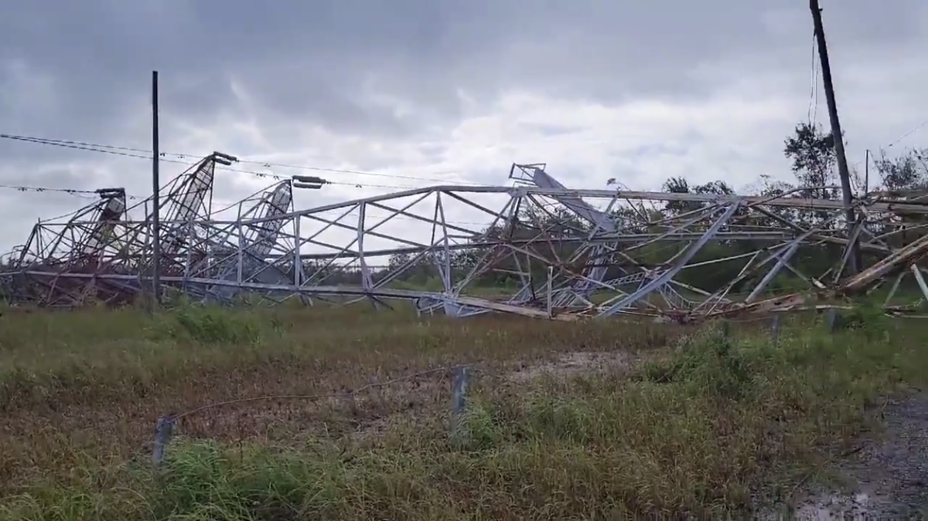
Major transmission tower collapsed near New Orleans

Initial Outage Map – August 30, 2021
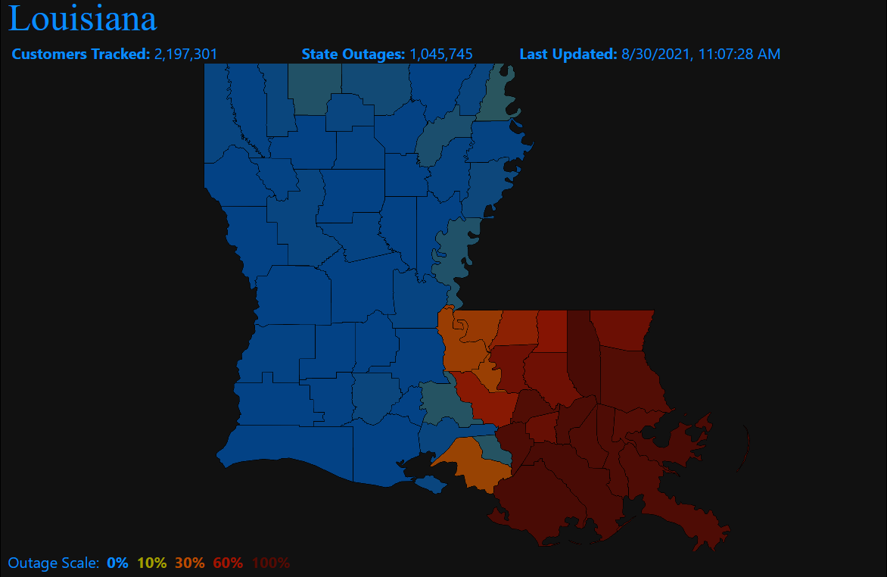

Courtesy of PowerOutage.us

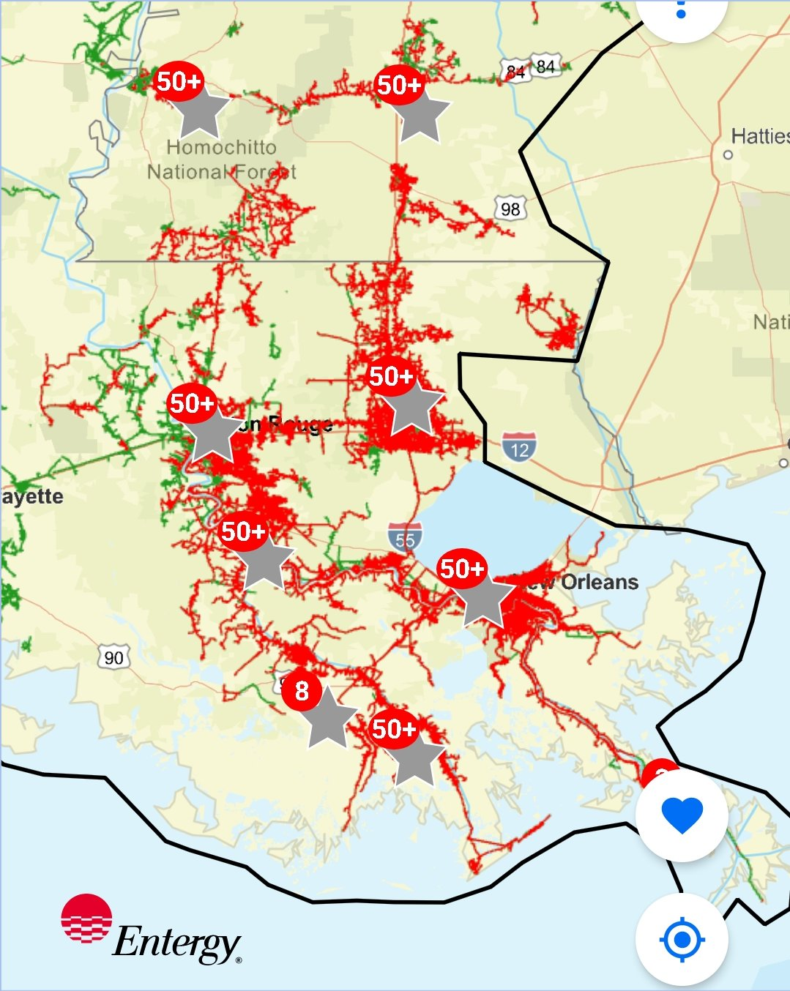
Courtesy of Entergy

August 6, 2021
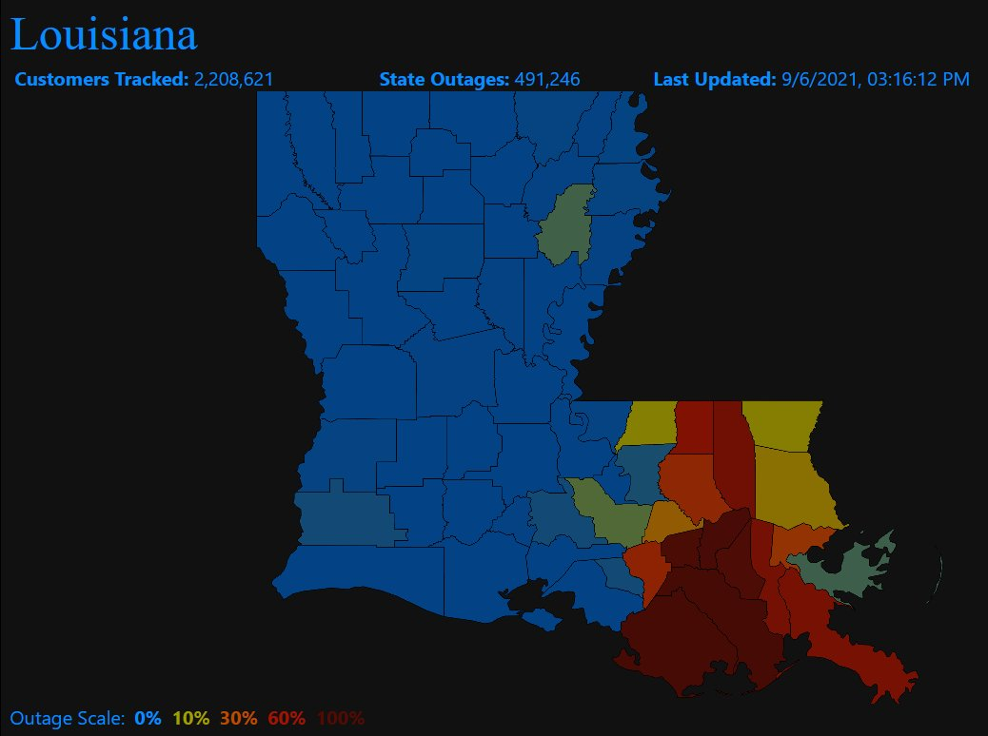
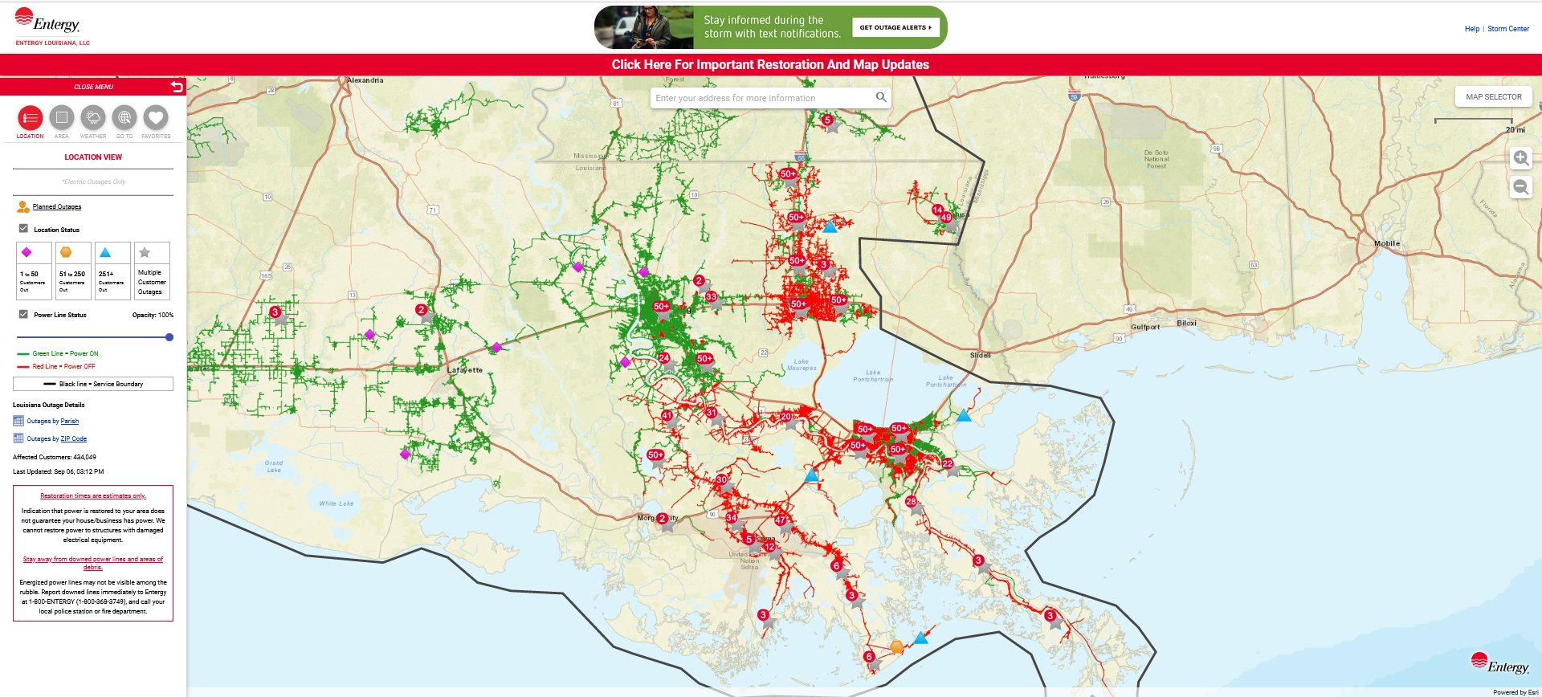

August 11, 2021
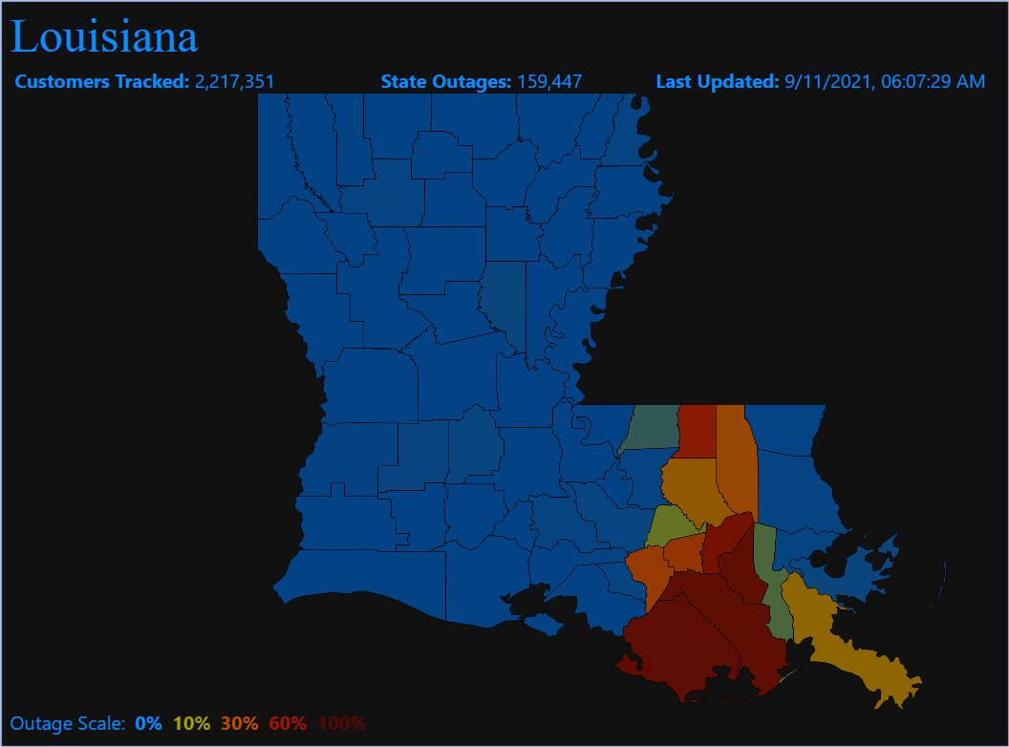
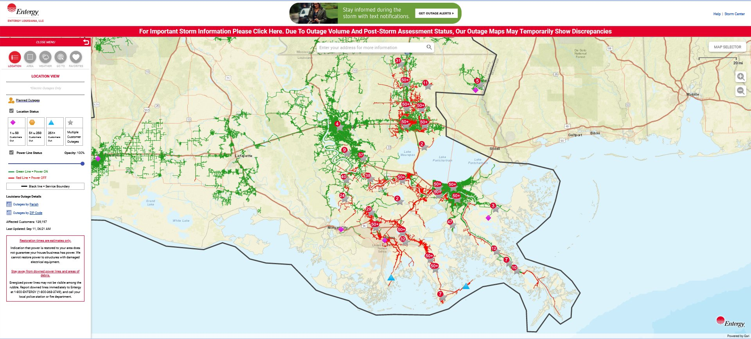

Damage Photos Port Fourchon, Grand Isle, Houma, and LaPlace
Courtesy of Representative Garret Graves

 | 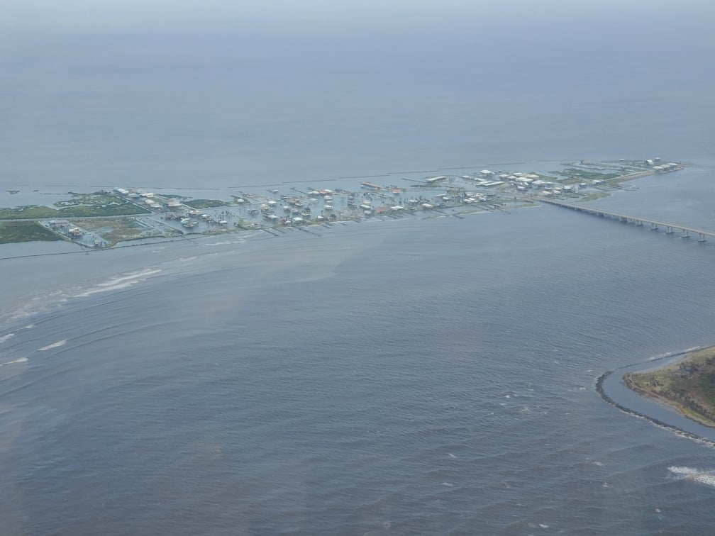
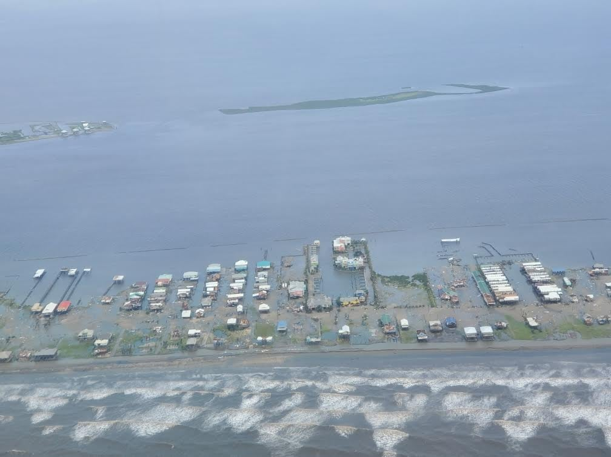 | 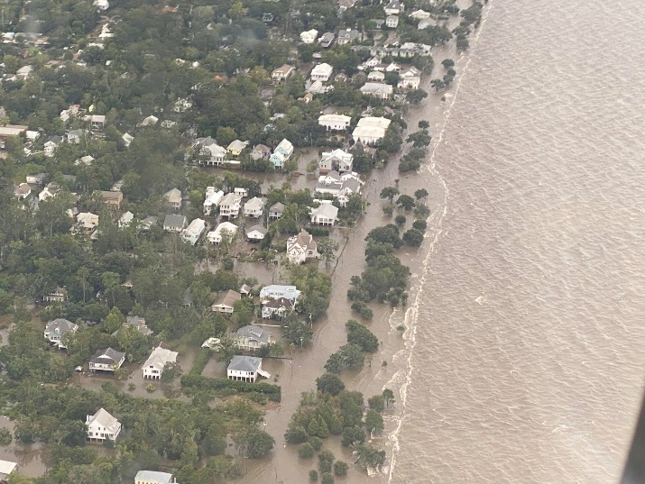
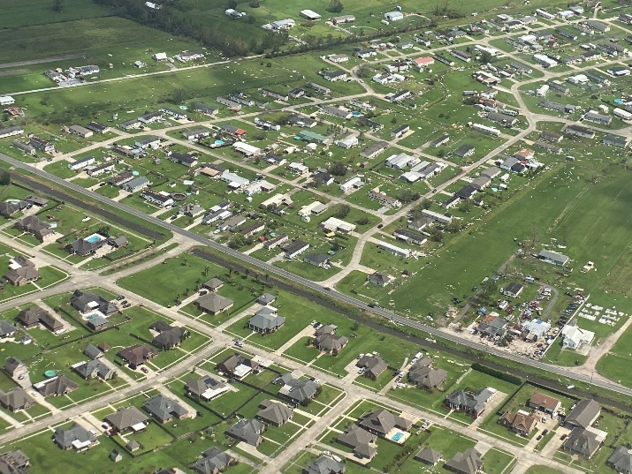 | 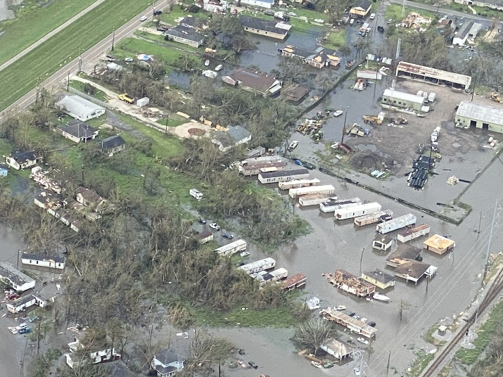

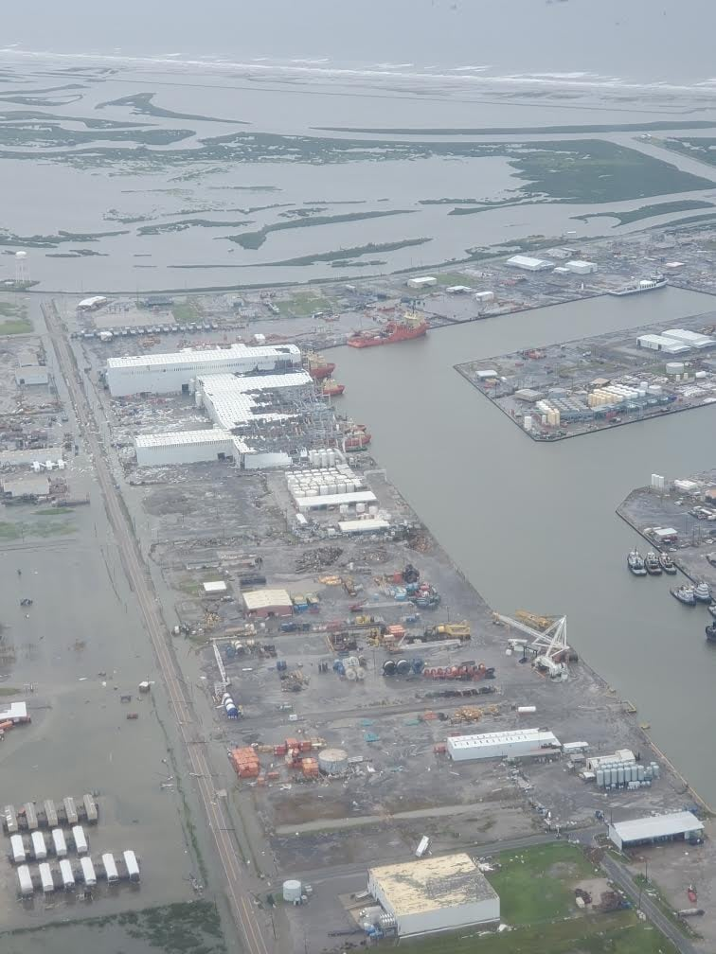 | 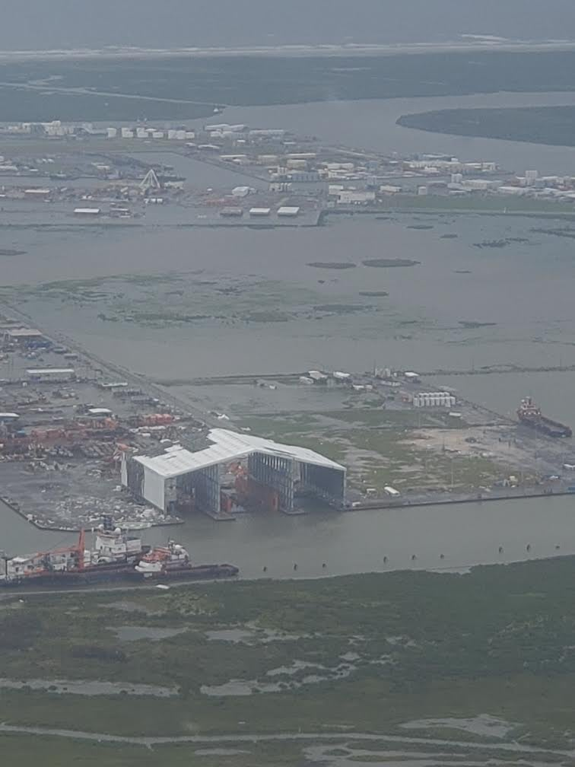
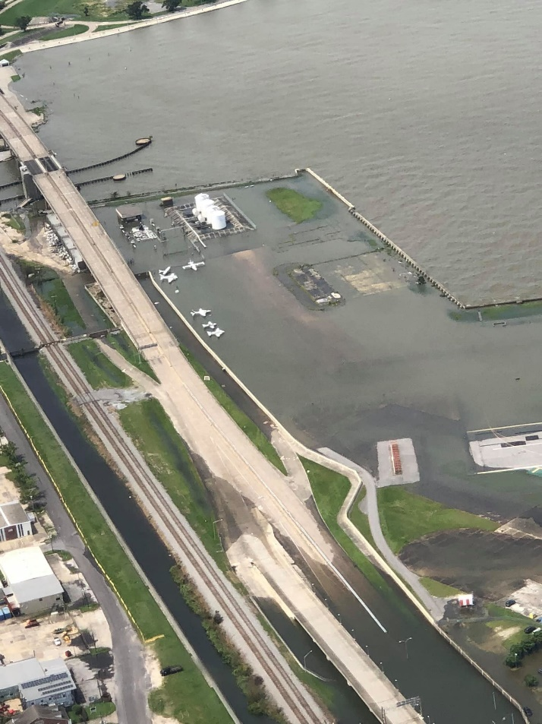 | 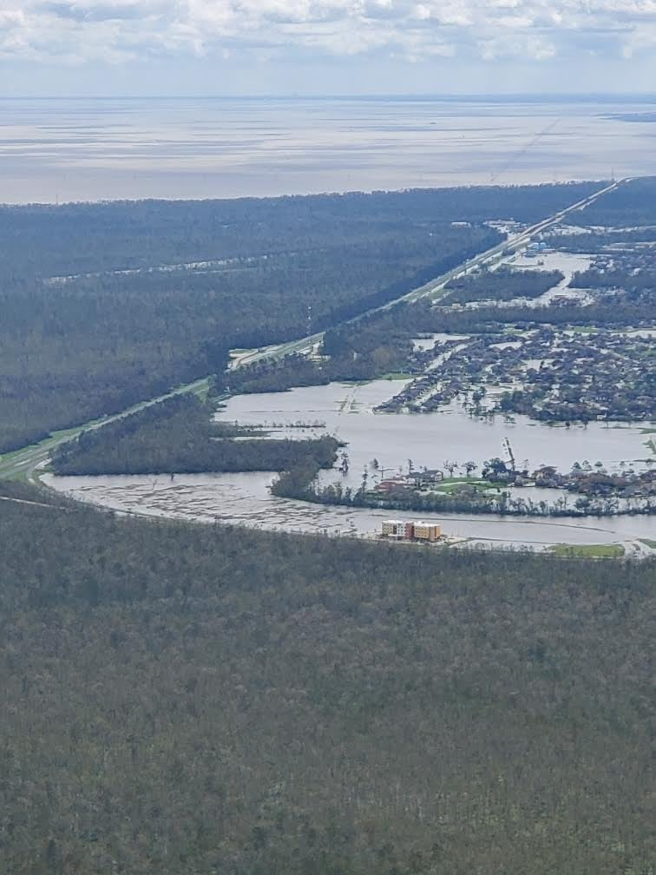

Landfalling Louisiana Hurricanes by Rank

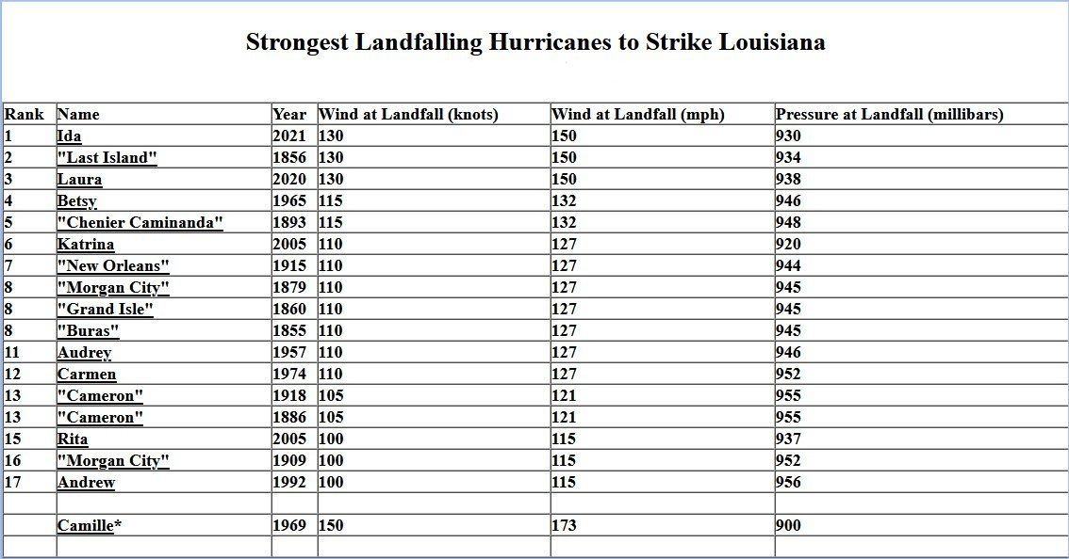

1856 Last Island Hurricane

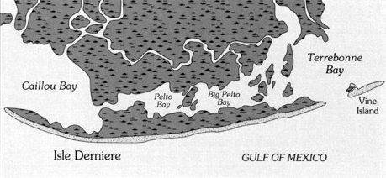

Additional Images


Louisiana State Police Assisting Workers Clearing Debris. Courtesy of Malmay and Associates


Monroe, Louisiana Mayor Ellis greeting guests seeking shelter. Courtesy of Malmay and Associates


Ouachita Parish EOC Briefing. Courtesy of Malmay and Associates


Coast Guard Prepping Flights Post Ida Landfall. Courtesy of Malmay and Associates


Terrebonne Parish buses parked at the Monroe, Louisiana Civic Center. Courtesy of Malmay and Associates.

References/Sources

Bayou State Weather
Entergy
Malmay and Associates
Louisiana Office of the Governor
National Hurricane Center, Miami Florida
NOLA.com
PowerOutage.us
Representative Garret Graves
St. Francis Weather Center/Gary Shuford
Tropical Tidbits
University of Wyoming

